Vertical Mouse Alternative for FPS and Ergonomic Enhancement

AJ Bwejesa
Ontario Tech University
100792221
Alex Bean
Ontario Tech University
100910379
Joseph Chanine
Ontario Tech University
100927087

Abstract— This project investigates the ergonomic and functional limitations of traditional computer mice during prolonged gaming sessions, particularly in first-person shooter (FPS) environments. Extended use of conventional horizontal mice has been associated with wrist discomfort, muscle fatigue, and increased risk of carpal tunnel syndrome. Additionally, traditional mouse aiming does not mimic natural forearm alignment, potentially limiting ergonomic efficiency and realism in FPS gameplay. The objective of this project is to design and prototype a vertical mouse alternative that improves ergonomic posture while integrating enhanced gaming functionality through embedded sensors, actuators, and a secondary display interface. The system was developed using an Arduino Uno microcontroller integrated with a force sensor, potentiometer, PIR sensor, and LED feedback system, alongside Unity game engine integration. A 3D prototype was created and tested using a Tinkercad simulation and a Unity scene visualization. Results demonstrate successful sensor-actuator communication and game input mapping. The major takeaway is that ergonomic redesign to a more comfortable and immersive input device can improve usage while potentially reducing wrist strain in long-term gaming use.
Keywords—ergonomics, mouse, fps, haptic, input device, human computer interaction, carpal tunnel, aiming

Introduction
Computer mice remain the dominant input device for both productivity and gaming. However, prolonged mouse usage has been associated with musculoskeletal disorders, including carpal tunnel syndrome (CTS), wrist extension strain, and forearm fatigue. FPS gaming intensifies these issues due to repetitive, high-precision movements. Vertical mice have been introduced commercially to address wrist pronation by promoting a neutral handshake posture. However, these devices are primarily productivity-oriented and are not optimized for competitive FPS gaming performance.
Traditional mice require sustained wrist pronation and repetitive micro-adjustments during long gaming sessions, contributing to discomfort and long-term strain. Additionally, existing vertical mice do not integrate features optimized for FPS gaming. This problem occurs during extended mouse usage. It affects gamers and daily PC users and as partial solutions (vertical mice), but few are tailored to FPS immersion and integrated feedback systems. The objective of this assignment is to design and prototype a vertical ergonomic mouse alternative optimized for FPS gameplay, integrating embedded electronics input mapping. If not addressed, prolonged mouse use may contribute to increased risk of musculoskeletal strain. [1] With FPS gaming requiring high repetition and precision, ergonomic optimization combined with gaming-specific enhancements has both health and performance implications.

Background Review

Keywords Used
Scientific literature was collected using Google Scholar and Omni search. Keywords used: vertical mouse ergonomics, carpal tunnel mouse posture, alternative mouse design, gaming mouse ergonomics, tactile feedback gaming, ergonomics, mouse, FPS, haptic, input device, aiming performance, HCI FPS aiming performance, gaming input devices, gamepad design shooter performance, FPS control. These keywords were used because they relate to the problems we are trying to address; testing ergonomic, immersive and customizable ways to develop a targeted input devices for FPS games. These keywords reflect the intended outcomes (ergonomics, usability, aiming performance), target users (gamers), and context (FPS gaming within HCI research). Roughly 20 sources were found and 9 used. Other sources were discarded because of either lack of information, access, or definitive conclusions.

Analysis and Takaways
Evaluation of flat, angled, and vertical computer mice demonstrated that increasing mouse height and angling the top case reduced forearm pronation without significantly affecting pointing performance [1]. However, fully vertical designs showed reduced performance despite posture improvements. These findings indicate that ergonomic gains must be balanced with precision and usability.
A systematic review of controlled trials examining alternative mouse designs reported moderate evidence supporting vertical and slanted mice in reducing discomfort, improving posture, and decreasing muscle activation [2]. However, the review emphasized that no single mouse design is universally optimal and that selection should be individualized based on user needs and task demands.
Research assessing carpal tunnel syndrome severity and hand discomfort across vertical, traditional, and flat mice found differences in ergonomic indicators, with vertical mice showing advantages in some posture-related measures [3]. Although not all differences were statistically significant, neutral wrist posture adoption was more common among vertical mouse users.
Additional experimental work comparing alternative mouse geometries among young adults evaluated wrist posture, movement performance, and subjective comfort [4]. While some alternative designs improved certain posture parameters, wrist extension above recommended thresholds was still observed in several configurations, reinforcing the complexity of ergonomic optimization.
A broader literature review examining computer input device design and musculoskeletal outcomes concluded that sustained non-neutral wrist postures and repetitive motion are associated with increased biomechanical loading [5]. Alternative designs may reduce exposure, but effectiveness varies across devices and contexts.
Electromyography-based analysis of gaming mouse use measured forearm muscle activation during high-intensity FPS gameplay [6]. Elevated muscle activation confirmed the potential risk of repetitive strain during prolonged gaming sessions, although differences between mouse designs were limited. These findings support the importance of ergonomic refinement specifically for gaming environments.
Beyond posture and muscle loading, interaction quality and immersion are also relevant to gaming devices. Investigation of vibrotactile feedback and interaction methods in VR environments demonstrated that tactile feedback enhanced presence and engagement under certain conditions [7]. Complementary work on haptics in gaming environments emphasized that force and tactile feedback can enhance immersion and user experience when integrated appropriately into interactive systems [8].
Finally, performance evaluation of alternative control methods in FPS/TPS environments using Fitts’ law testing showed that touch-based inputs can approach mouse-level precision when latency conditions are controlled [9]. These results highlight that responsiveness, input mapping, and system latency are critical for maintaining competitive performance while exploring alternative ergonomic configurations.
Collectively, the literature supports the investigation of a vertically oriented gaming mouse that aims to reduce biomechanical strain while maintaining performance and enhancing user experience through integrated feedback mechanisms.
These studies establish two core insights: Vertical orientation reduces ergonomic strain compared to traditional mouse posture. Gaming performance is highly sensitive to latency, mapping naturalism, and feedback integration.

Commercial products
Three commercial devices were examined to understand the current landscape of ergonomic and gaming mouse design.

The Logitech MX Vertical features a 57-degree vertical orientation intended to reduce wrist pronation and muscle strain. It is primarily designed for office productivity and does not emphasize high-DPI sensors or low-latency gaming performance. Similarly, the 3M Ergonomic Vertical Mouse adopts a handshake-style grip focused on medical ergonomics, but lacks gaming-specific features such as adjustable DPI or competitive responsiveness.

Conversely, the Razer Viper represents a performance-focused gaming mouse with high-DPI optical sensors and low-latency switches optimized for FPS precision. However, it retains the traditional horizontal posture associated with wrist pronation.
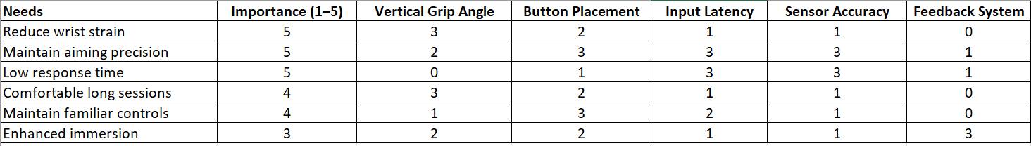
Prototype Design
A vertical mouse alternative was developed by removing the casing of a traditional mouse and designing a vertical grip structure using Blender. The design includes a top trigger acting as left click, a secondary button below it acting as right click, a scroll wheel mechanism, and a side button corresponding to mouse button four. The concept also includes a mini screen component intended for auxiliary visual feedback.

A Blender model was created to represent the physical structure of the device. The Unity environment was used to simulate device interaction and visualize how the mini screen concept would function using a standard monitor for testing purposes.

Electronics Implementation
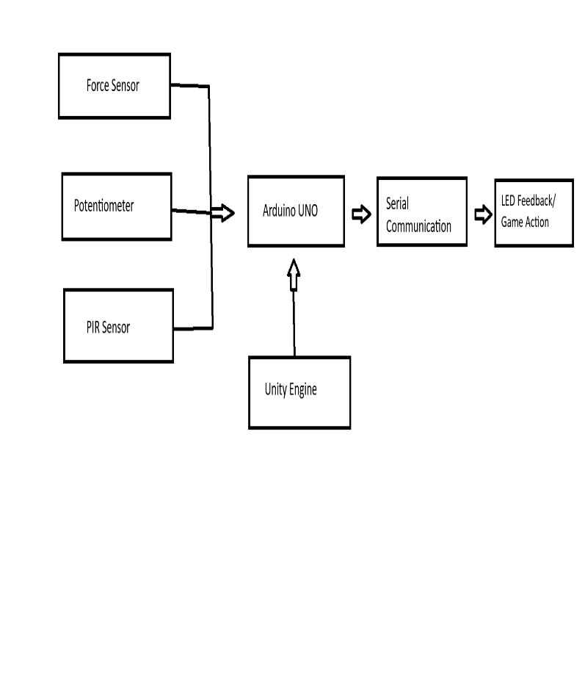
The electronic system was implemented using an Arduino Uno microcontroller. Three sensors were integrated into the system: a force sensor to simulate scroll activation, a potentiometer to determine scroll direction, and a PIR sensor to simulate surface movement detection like a traditional optical mouse sensor.
System Architecture
Three LED actuators were connected to represent button activation states. Buttons were used to simulate primary mouse inputs. The Arduino reads sensor and button inputs through digital and analog pins and executes programmed conditional logic. When defined thresholds are met, the corresponding LED outputs are activated.

Appendix A - Arduino Code
Arduino Code:
// C++ code
//
void setup()
{
pinMode(1, INPUT);
pinMode(11, OUTPUT);
pinMode(2, INPUT);
pinMode(12, OUTPUT);
pinMode(3, INPUT);
pinMode(13, OUTPUT);
pinMode(4, INPUT);
pinMode(6, INPUT);
pinMode(10, OUTPUT);
pinMode(5, INPUT);
pinMode(9, OUTPUT);
}

void loop()
{
if (digitalRead(1) == HIGH) {
digitalWrite(11, HIGH);
} else {
digitalWrite(11, LOW);
}
if (digitalRead(2) == HIGH) {
digitalWrite(12, HIGH);
} else {
digitalWrite(12, LOW);
}
if (digitalRead(3) == HIGH) {
digitalWrite(13, HIGH);
} else {
digitalWrite(13, LOW);
}
if (digitalRead(4) <= 0.1 && digitalRead(6) > 0.75) {
digitalWrite(10, HIGH);
} else {
digitalWrite(10, LOW);
}
if (digitalRead(5) >= 1 && digitalRead(6) > 0.75) {
digitalWrite(9, HIGH);
} else {
digitalWrite(9, LOW);
}
delay(10); // Delay a little bit to improve simulation performance
}

Appendix B - Tinkercad
A Tinkercad simulation was completed to verify wiring configuration and system functionality. The simulation confirmed that sensor inputs and button presses triggered the appropriate LED outputs. The Arduino code processed input states and executed output commands consistently within the simulated environment.
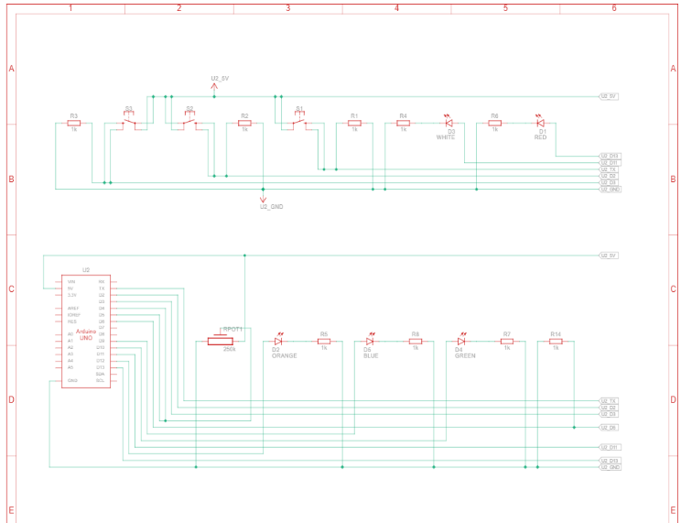
Appendix C - Unity Integration
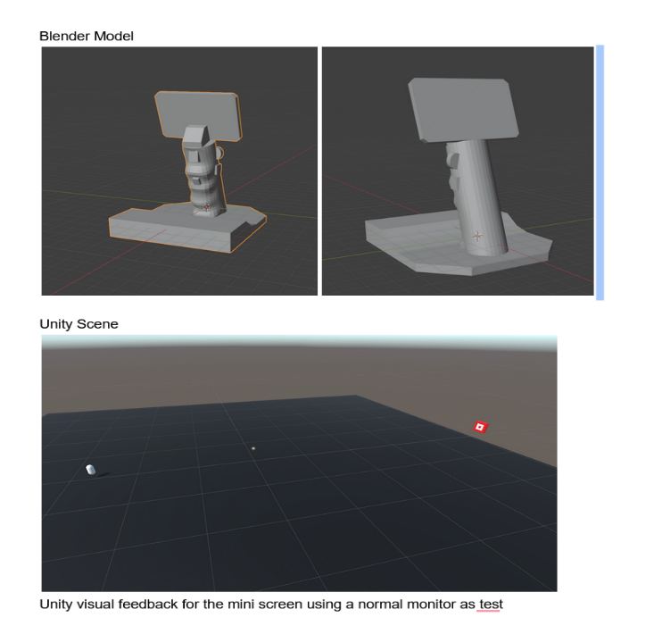
A Unity scene was created to simulate game interaction using the proposed device. Input mappings were assigned to aiming and camera movement within the Unity environment. Visual feedback for the mini screen concept was tested using a standard monitor as a placeholder display.

The Unity simulation demonstrated that hardware inputs could be mapped to game functionality and that the concept supports integration between physical inputs and a game engine environment. This validated the feasibility of combining ergonomic hardware redesign with interactive software functionality.
Appendix D – Ideation & Design Thinking Process

Results

The project followed a simplified human-centered design thinking approach. Initial discussions with classmates and other FPS gamers identified potential wrist fatigue, forearm strain as possible concerns. The problem was defined as improving ergonomic posture without compromising aiming precision or responsiveness. Multiple concepts were explored, including fully vertical and angled grip designs, trigger-style primary click placement, and integrated feedback features. A Blender prototype and Arduino–Unity integration were used to test feasibility and input behavior. Feedback emphasized maintaining familiar controls, minimizing bulk, and preserving low-latency responsiveness. The final concept reflects a balance between ergonomic improvement and competitive gaming performance.
Before Design Thinking (Typical Mouse Use Case)
- User sits at desk and grips horizontal mouse.
- Wrist is pronated (palm facing down).

- User performs repeated micro-adjustments for aiming.
- User clicks left button to fire.
- Extended use results in wrist fatigue and discomfort.
After Design Thinking (Vertical Mouse Use Case)
- User grips mouse in handshake posture.
- Wrist remains in more neutral alignment.
- Trigger-style button used for primary click.
- Potentiometer controls scroll or directional input.
- LED indicators provide visual feedback during input.
- Reduced pronation potentially reduces strain. Enhanced Immersive Feel
The Unity scene demonstrated that hardware inputs could be mapped to game functionality and that the concept supports integration between physical inputs and a game engine. This validated the feasibility of combining ergonomic hardware redesign with interactive software functionality.

Appendix E – Contributions

Alex was responsible for the hardware implementation of the prototype. This included identifying and integrating three sensors and three actuators, designing the wiring diagram, writing the Arduino code, and completing the simulation/ physical build. They also recorded a demonstration video of the working electronic system. They provided the list of sensors and actuators, specified the microcontroller used, included a schematic screenshot, documented the simulation results, and described the data flow.

Joseph was responsible for software integration and Unity development. This included creating the Unity scene, reading sensor data, mapping hardware inputs to aiming and camera movement, implementing visual feedback for the mini screen concept, and recording a demonstration of the Unity interaction. They provided the Unity scene screenshot, explained how inputs affect in-game behavior, and supplied the demo recording.

AJ was responsible for research and documentation. This included identifying and analyzing nine academic sources and three commercial products, documentation, defining project keywords, analysis, and combining the info in the written report.
Appendix F – AI Usage
AI tools were used to assist with document organization and verification of formatting structure and assignment requirements.

Appendix G – Future Work Plan
Week 1
Reevaluate Purpose & Modifications Review project goals, adjust grip shape and button placement, refine overall design direction
Week 2
Hardware & Software Refinement Improve wiring layout, stabilize electronics, optimize Unity input mapping and responsiveness
Week 3
User Testing Conduct small gameplay testing sessions, collect feedback on comfort and aiming performance
Week 4
Improvements & Iteration Implement design adjustments based on feedback, refine structure and input behavior

Conclusion
This project developed a vertical mouse alternative intended for FPS gaming and ergonomic improvement. A Blender model was created to represent the vertical grip design, and an Arduino-based electronic system was implemented using sensors and LED outputs. A Tinkercad simulation verified the circuit functionality, and Unity was used to test input mapping and visual feedback. The prototype demonstrates the integration of hardware inputs with software interaction and provides a foundation for further refinement of the design. Future development would include physical fabrication refinement, latency testing against commercial gaming mice, and empirical ergonomic measurement through controlled user trials.

References
[1] D. Odell and P. Johnson, “Evaluation of flat, angled, and vertical computer mice and their effects on wrist posture, pointing performance, and preference,” Work, vol. 52, pp. 245–253, 2015. DOI: 10.3233/WOR-152167

[2] A. Radwan, T. Kallasy, A. Monroe, E. Chrisman, and O. Carpenter, “Benefits of alternative computer mouse designs: A systematic review of controlled trials,” Cogent Engineering, vol. 5, no. 1, 2018. DOI: 10.1080/23311916.2018.1521503

[3] E. Oveisi, P. Khanlari, and M. Ebrahimzadeh-Afrouzi, “Carpal tunnel syndrome severity, hand discomfort, and usability among three types of computer mouse,” Work, vol. 77, pp. 873–882, 2024. DOI: 10.3233/WOR-220492

[4] D. J. Feathers, K. Rollings, and A. Hedge, “Alternative computer mouse designs: Performance, posture, and subjective evaluations for college students aged 18–25,” Work, vol. 44, pp. S115–S122, 2013. DOI: 10.3233/WOR-121487

[5] J. L. Bruno Garza and J. G. Young, “A literature review of the effects of computer input device design on biomechanical loading and musculoskeletal outcomes during computer work,” Work, vol. 52, pp. 217–230, 2015. DOI: 10.3233/WOR-152161

[6] R. A. Zafs et al., “Ergonomic analysis of gaming mouse using electromyography and subjective assessment,” Journal of Mechatronics, Electrical Power, and Vehicular Technology, vol. 15, no. 2, pp. 177–185, 2024. DOI: 10.55981/j.mev.2024.1110

[7] H. S. Moon, “The effect of interaction method and vibrotactile feedback on user experience and performance in VR games,” M.S. thesis, Virginia Polytechnic Institute and State University, Blacksburg, VA, USA, 2022.

[8] M. Orozco, J. Silva, A. El Saddik, and E. Petriu, “The role of haptics in games,” in Haptics Rendering and Applications, InTech, 2012.
[9] C.-E. Chen and F.-W. Tung, “Gamepad design for touch generation: Evaluation of first-person shooter/third-person shooter game control and possibility of touch-based control as norm,” Engineering Proceedings, vol. 55, 2023. DOI: 10.3390/engproc2023055092

